# Study Watch Firmware Upgrade using Android App

This document lists down the steps to do Firmware Upgrade on Study Watch via BLE using Android App.

## Firmware Upgrade with BLE Transport

1. For doing firmware upgrade via BLE using Android mobile application, press two buttons on DVT1 watch for 5 seconds. This takes it to the bootloader stage, and it waits for DFU with “an arrow icon”, as shown in Figure 1

Figure DVT1 Watch in bootloader mode

1. The Watch will remain in Bootloader stage for 2 minutes, after which it gets auto cancelled and loads the application image, if present.
2. Move the ADI_project.zip file in package to your Android phone and open the “nRF connect” mobile application.

( For details, refer to <https://www.nordicsemi.com/Software-and-Tools/Development-Tools/nRF-Connect-for-mobile> to find out how to install the APP)

1. Scan for the BLE advertisement from the nRF Connect APP. When the APP finds the ADI_dfu, select the CONNECT button to establish the connection as in Figure 2

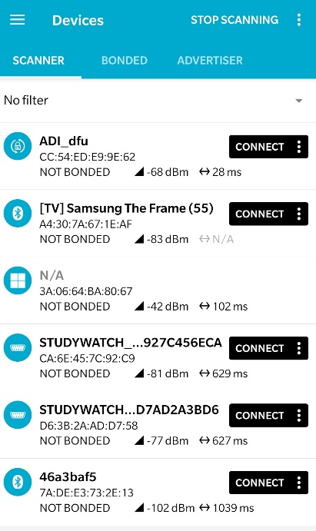

Figure nRF Connect app Scan Results showing "ADI_dfu" device name

1. After connected to the DVT1 board, click the “DFU” icon as marked in Figure 3

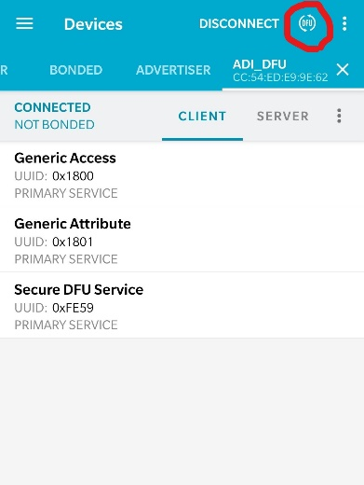

Figure nRF Connect app DFU icon marked

1. A dialog box “Select file type” will pop up, make no change and click “OK” to find the upgrade .zip file from your phone. After the ADI_project.zip file is found, select it and then start the BLE upgrade starts

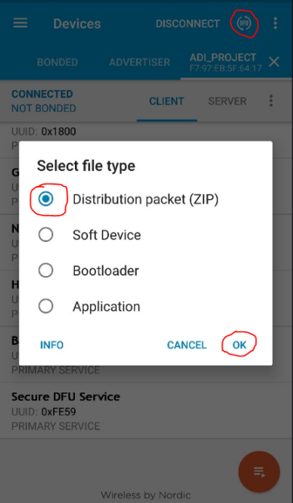

Figure nRF Connect Upgrade zip package selection

1. The Graph showing the transfer details will appear. It is to be noted that, it will take a while to start and complete the transfer – 2-4 minutes. Please wait for the update to complete.

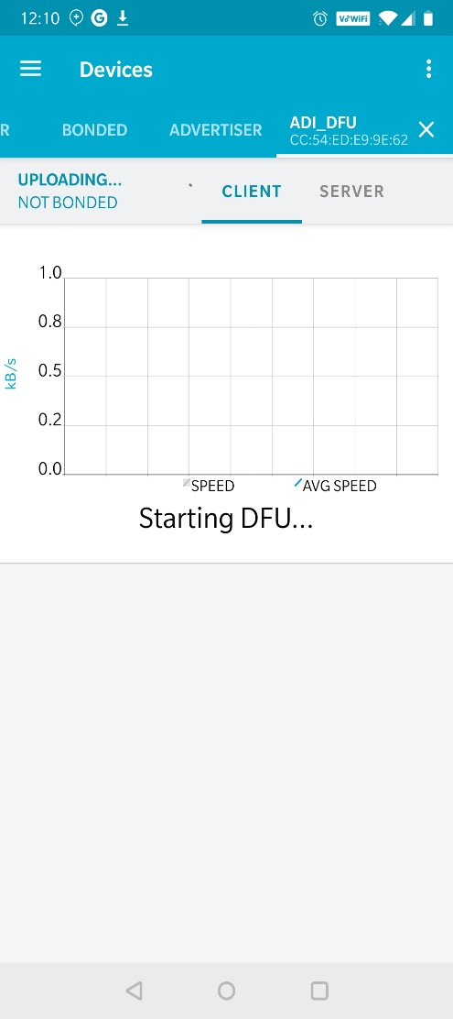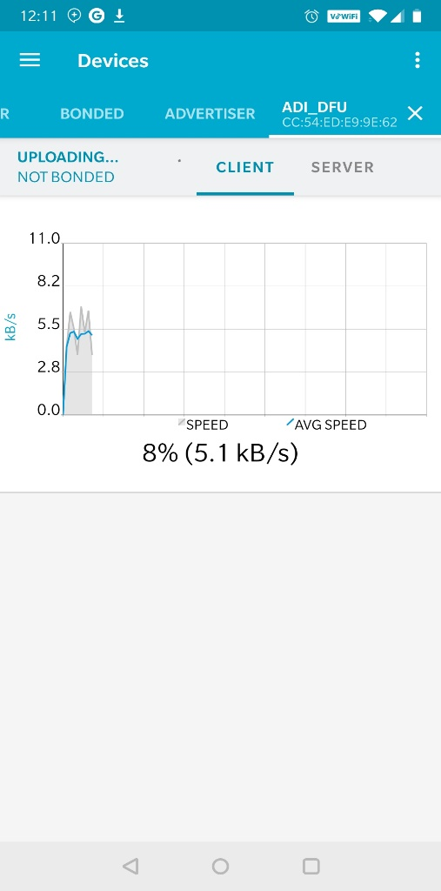

Figure nRF Connect package upgrade status graph

1. After the upgrade process is completed, the APP will automatically close the window and go back to the previous Tab with “ADI_DFU” showing its not connected. This happens because the Watch isn’t in bootloader stage and has a different device name.

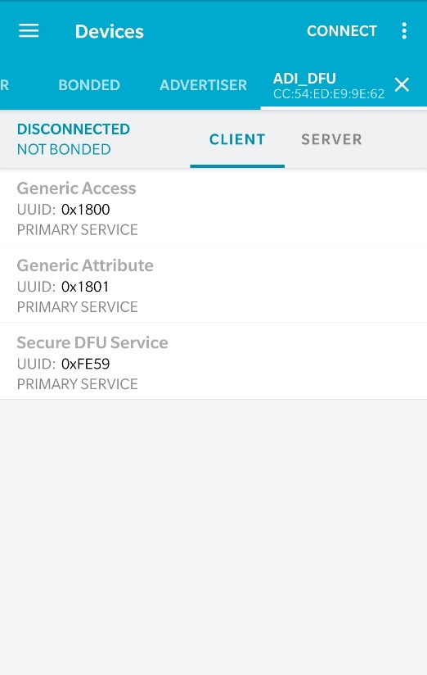

Figure nRF Connect app, after upgrade is completed

1. If you want to test the firmware upgrade via BLE upgrade again, please return to step 1 above and repeat the process.